- Implement Bresenham’s Line Drawing Algorithm

import matplotlib.pyplot as plt

def bresenham_line(x1, y1, x2, y2):
points = []
dx = abs(x2 - x1)
dy = abs(y2 - y1)
sx = 1 if x2 > x1 else -1
sy = 1 if y2 > y1 else -1
err = dx - dy

while True:
points.append((x1, y1))

if x1 == x2 and y1 == y2:
break

e2 = 2 * err

if e2 > -dy:
err -= dy
x1 += sx

if e2 < dx:
err += dx
y1 += sy

return points

def main():
print("Bresenham's Line Drawing Algorithm")
try:
x1 = int(input("Enter x1: "))
y1 = int(input("Enter y1: "))
x2 = int(input("Enter x2: "))
y2 = int(input("Enter y2: "))

points = bresenham_line(x1, y1, x2, y2)

# Extract x and y coordinates
x_coords, y_coords = zip(*points)

# Plotting the line
plt.plot(x_coords, y_coords, marker='o', color='blue')
plt.title("Bresenham's Line Drawing")
plt.xlabel("X-axis")
plt.ylabel("Y-axis")
plt.grid(True)
plt.gca().set_aspect('equal', adjustable='box')
plt.show()

except ValueError:
print("Please enter valid integer values.")

if __name__ == "__main__":
main()

OUTPUT
Bresenham's Line Drawing Algorithm
Enter x1: 4
Enter y1: 5
Enter x2: 13
Enter y2: 16
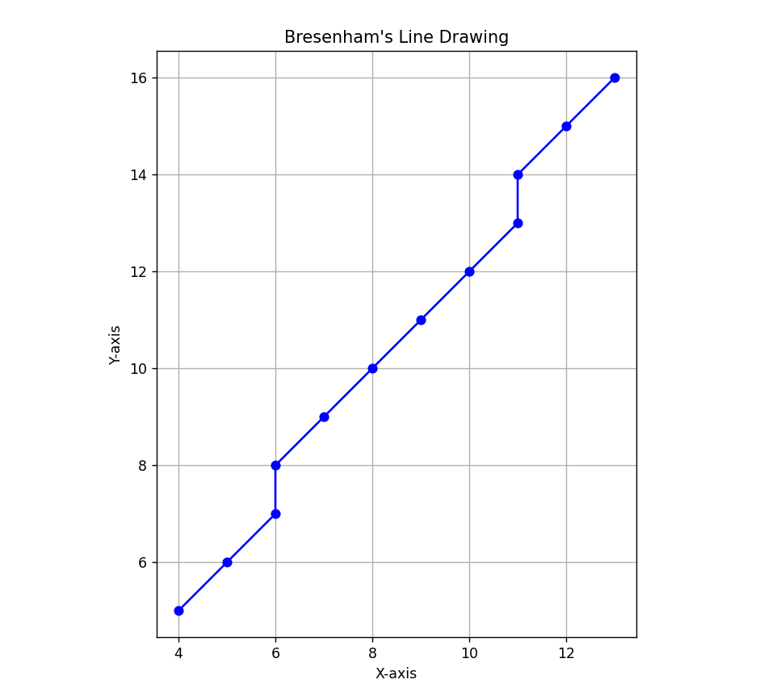

- Implement Cohen-Sutherland Line Clipping Algorithm

import matplotlib.pyplot as plt
INSIDE, LEFT, RIGHT, BOTTOM, TOP = 0, 1, 2, 4, 8

def compute_code(x, y, rect):
xmin, xmax, ymin, ymax = rect
return (LEFT if x < xmin else RIGHT if x > xmax else 0) | \
(BOTTOM if y < ymin else TOP if y > ymax else 0)

def clip_line(x1, y1, x2, y2, rect):
code1, code2 = compute_code(x1, y1, rect), compute_code(x2, y2, rect)
while True:
if not (code1 | code2):
return x1, y1, x2, y2
elif code1 & code2:
return None
out = code1 or code2
xmin, xmax, ymin, ymax = rect
if out & TOP: x = x1 + (x2 - x1) * (ymax - y1) / (y2 - y1); y = ymax
elif out & BOTTOM:x = x1 + (x2 - x1) * (ymin - y1) / (y2 - y1); y = ymin
elif out & RIGHT: y = y1 + (y2 - y1) * (xmax - x1) / (x2 - x1); x = xmax
elif out & LEFT: y = y1 + (y2 - y1) * (xmin - x1) / (x2 - x1); x = xmin
if out == code1: x1, y1, code1 = x, y, compute_code(x, y, rect)
else: x2, y2, code2 = x, y, compute_code(x, y, rect)

def main():
print("Cohen–Sutherland Line Clipping")
x1, y1 = map(float, input("Enter x1 y1: ").split())
x2, y2 = map(float, input("Enter x2 y2: ").split())
rect = tuple(map(float, input("Enter xmin xmax ymin ymax: ").split()))
clipped = clip_line(x1, y1, x2, y2, rect)

fig, ax = plt.subplots()
ax.add_patch(plt.Rectangle((rect[0], rect[2]), rect[1]-rect[0], rect[3]-rect[2], edgecolor='black', fill=False, linestyle='--'))
ax.plot([x1, x2], [y1, y2], 'r--', label="Original Line")
if clipped:
ax.plot([clipped[0], clipped[2]], [clipped[1], clipped[3]], 'g-', label="Clipped Line")
else:
print("Line is completely outside the clipping window.")

plt.title("Cohen–Sutherland Line Clipping")
plt.xlabel("X"); plt.ylabel("Y"); plt.grid(True); plt.axis('equal'); plt.legend()
plt.show()

if __name__ == "__main__":
main()
OUTPUT
Cohen–Sutherland Line Clipping
Enter x1 y1: 30 30
Enter x2 y2: 250 250
Enter xmin xmax ymin ymax: 50 200 50 200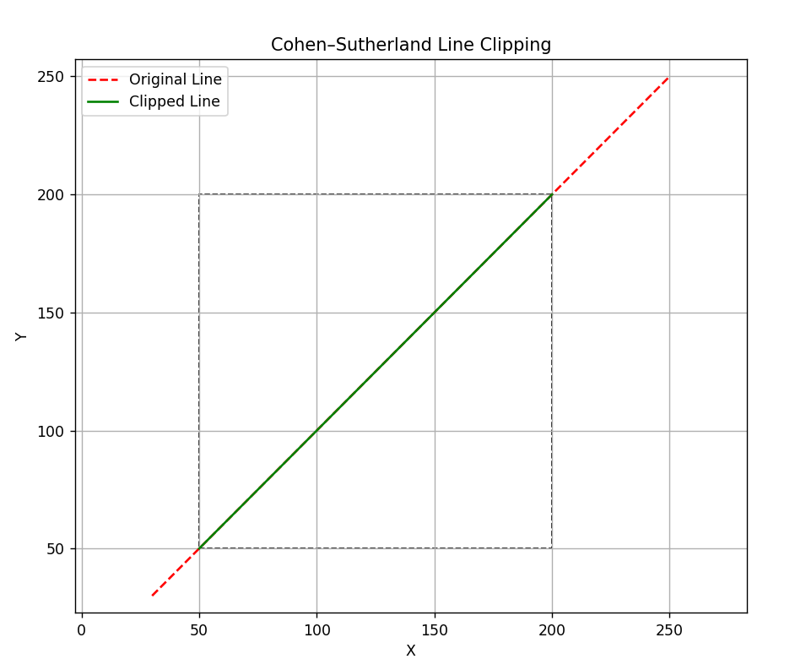

- Implement Midpoint Circle Drawing Algorithm

import matplotlib.pyplot as plt

def plot_circle_points(xc, yc, x, y, points):
# 8-way symmetry
points.extend([
(xc + x, yc + y),
(xc - x, yc + y),
(xc + x, yc - y),
(xc - x, yc - y),
(xc + y, yc + x),
(xc - y, yc + x),
(xc + y, yc - x),
(xc - y, yc - x)
])

def midpoint_circle(xc, yc, r):
x = 0
y = r
d = 1 - r
points = []

while x <= y:
plot_circle_points(xc, yc, x, y, points)

if d < 0:
d = d + 2 * x + 3
else:
d = d + 2 * (x - y) + 5
y -= 1

x += 1

return points

def main():
print("Midpoint Circle Drawing Algorithm")
try:
xc = int(input("Enter center x-coordinate: "))
yc = int(input("Enter center y-coordinate: "))
r = int(input("Enter radius: "))

if r < 0:
raise ValueError("Radius must be non-negative.")

points = midpoint_circle(xc, yc, r)

# Extract x and y coordinates
x_coords, y_coords = zip(*points)

# Plotting the circle
plt.scatter(x_coords, y_coords, color='purple')
plt.title("Midpoint Circle Drawing")
plt.xlabel("X-axis")
plt.ylabel("Y-axis")
plt.grid(True)
plt.gca().set_aspect('equal', adjustable='box')
plt.show()

except ValueError as e:
print("Error:", e)

if __name__ == "__main__":
main()

OUTPUT
Midpoint Circle Drawing Algorithm
Enter center x-coordinate: -3
Enter center y-coordinate: 1
Enter radius: 13
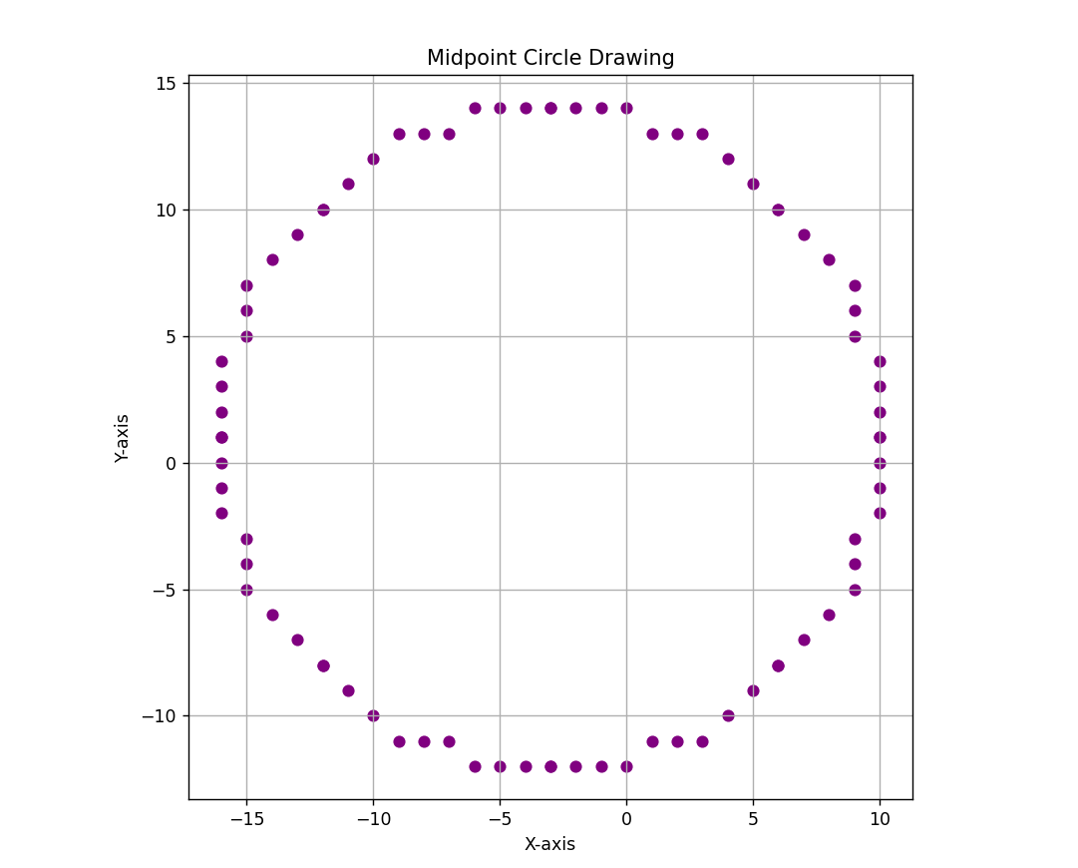

- Polygon Clipping using Sutherland-Hodgman Algorithm

import matplotlib.pyplot as plt

def inside(p, edge, rect):
x, y = p; xmin, xmax, ymin, ymax = rect
return (x >= xmin if edge == 'LEFT' else
x <= xmax if edge == 'RIGHT' else
y >= ymin if edge == 'BOTTOM' else
y <= ymax)

def intersect(p1, p2, edge, rect):
x1, y1 = p1; x2, y2 = p2; xmin, xmax, ymin, ymax = rect
dx, dy = x2 - x1, y2 - y1
if dx == 0: m = float('inf')
else: m = dy / dx

if edge == 'LEFT': return (xmin, y1 + m * (xmin - x1))
if edge == 'RIGHT': return (xmax, y1 + m * (xmax - x1))
if edge == 'BOTTOM': return (x1 if m == float('inf') else x1 + (ymin - y1) / m, ymin)
if edge == 'TOP': return (x1 if m == float('inf') else x1 + (ymax - y1) / m, ymax)

def sutherland_hodgman(polygon, rect):
for edge in ['LEFT', 'RIGHT', 'BOTTOM', 'TOP']:
output = []
s = polygon[-1]
for e in polygon:
if inside(e, edge, rect):
if not inside(s, edge, rect): output.append(intersect(s, e, edge, rect))
output.append(e)
elif inside(s, edge, rect):
output.append(intersect(s, e, edge, rect))
s = e
polygon = output
return polygon

def main():
print("Sutherland–Hodgman Polygon Clipping")
n = int(input("Enter number of vertices: "))
polygon = [tuple(map(float, input(f"Enter x[{i+1}], y[{i+1}]: ").split())) for i in range(n)]
rect = tuple(map(float, input("Enter xmin, xmax, ymin, ymax: ").split()))
clipped = sutherland_hodgman(polygon, rect)

fig, ax = plt.subplots()
ax.plot(*zip(*(polygon + [polygon[0]])), 'r--', label='Original')
if clipped:
ax.plot(*zip(*(clipped + [clipped[0]])), 'g-', label='Clipped')
ax.add_patch(plt.Rectangle((rect[0], rect[2]), rect[1]-rect[0], rect[3]-rect[2], edgecolor='black', fill=False, linestyle='--', label='Clip Window'))
plt.title("Sutherland–Hodgman Polygon Clipping")
plt.xlabel("X"); plt.ylabel("Y"); plt.legend(); plt.grid(True)
ax.set_aspect('equal', adjustable='box'); plt.show()

if __name__ == "__main__":
main()

OUTPUT
Sutherland–Hodgman Polygon Clipping
Enter number of vertices: 4
Enter x[1], y[1]: 30 30
Enter x[2], y[2]: 180 50
Enter x[3], y[3]: 220 180
Enter x[4], y[4]: 50 220
Enter xmin, xmax, ymin, ymax: 50 200 50 200 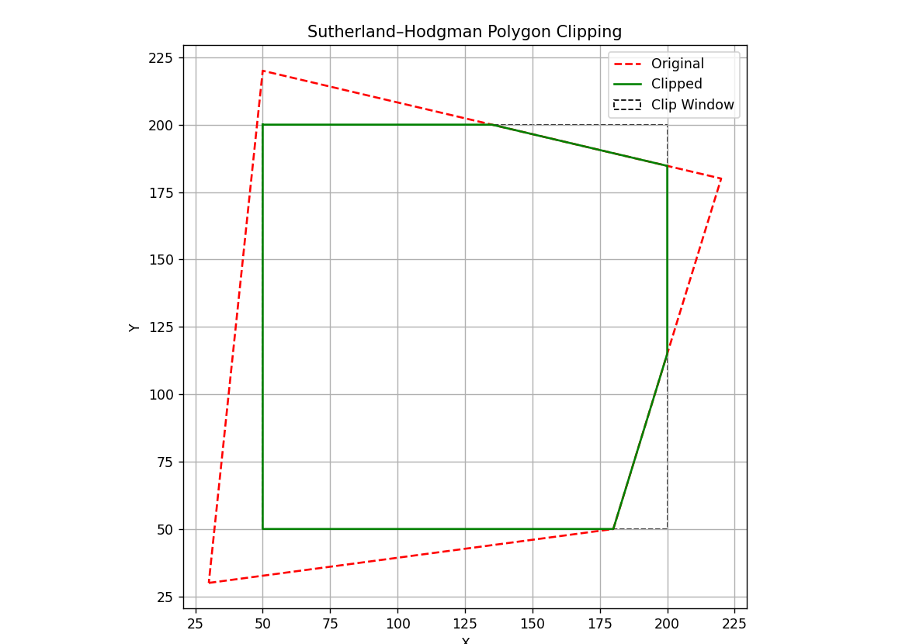

- WAP to apply various 2D Transformations on a 2D object.

import numpy as np
import matplotlib.pyplot as plt

def get_polygon():
n = int(input("Enter number of vertices: "))
return np.array([[*map(float, input(f"x[{i+1}] y[{i+1}]: ").split()), 1] for i in range(n)])

def transform(p, mat): return p @ mat.T

def matrices():
return {
'1': lambda: np.array([[1, 0, float(input("tx: "))], [0, 1, float(input("ty: "))], [0, 0, 1]]),
'2': lambda: np.array([[float(input("sx: ")), 0, 0], [0, float(input("sy: ")), 0], [0, 0, 1]]),
'3': lambda: (lambda a: np.array([[np.cos(a), -np.sin(a), 0], [np.sin(a), np.cos(a), 0], [0, 0, 1]]))(np.radians(float(input("Angle (deg): ")))),
'4': lambda: np.array([[1, float(input("shx: ")), 0], [float(input("shy: ")), 1, 0], [0, 0, 1]]),
'5': lambda: {'x': [[1, 0, 0], [0, -1, 0], [0, 0, 1]], 'y': [[-1, 0, 0], [0, 1, 0], [0, 0, 1]], 'origin': [[-1, 0, 0], [0, -1, 0], [0, 0, 1]]}[input("Axis (x/y/origin): ").lower()]
}

def plot(polygon, transformed):
def close(p): return np.vstack([p[:, :2], p[0, :2]])
plt.clf()
plt.plot(*close(polygon).T, 'ro--', label="Original")
plt.plot(*close(transformed).T, 'go-', label="Transformed")
plt.title("2D Transformation"); plt.xlabel("X"); plt.ylabel("Y")
plt.legend(); plt.axis('equal'); plt.grid(True)
plt.pause(0.1)

def main():
print("2D Transformations using Homogeneous Coordinates")
polygon = get_polygon()
transformed = polygon.copy()
plt.ion(); plt.figure()

while True:
print("\n1: Translate 2: Scale 3: Rotate 4: Shear 5: Reflect q: Quit")
choice = input("Choose transformation: ")
if choice == 'q': break

if choice in matrices():
try:
mat = np.array(matrices()[choice](), dtype=float)
transformed = transform(transformed, mat)
plot(polygon, transformed)
except: print("Invalid input.")
else:
print("Invalid choice.")
plt.ioff(); plt.show()

if __name__ == "__main__":
main()

OUTPUT
2D Transformations using Homogeneous Coordinates
Enter number of vertices: 4
x[1] y[1]: 0 0
x[2] y[2]: 1 0
x[3] y[3]: 1 1
x[4] y[4]: 0 1

1: Translate
2: Scale
3: Rotate
4: Shear
5: Reflect
q: Quit
Choose transformation: 3
Angle (deg): 45
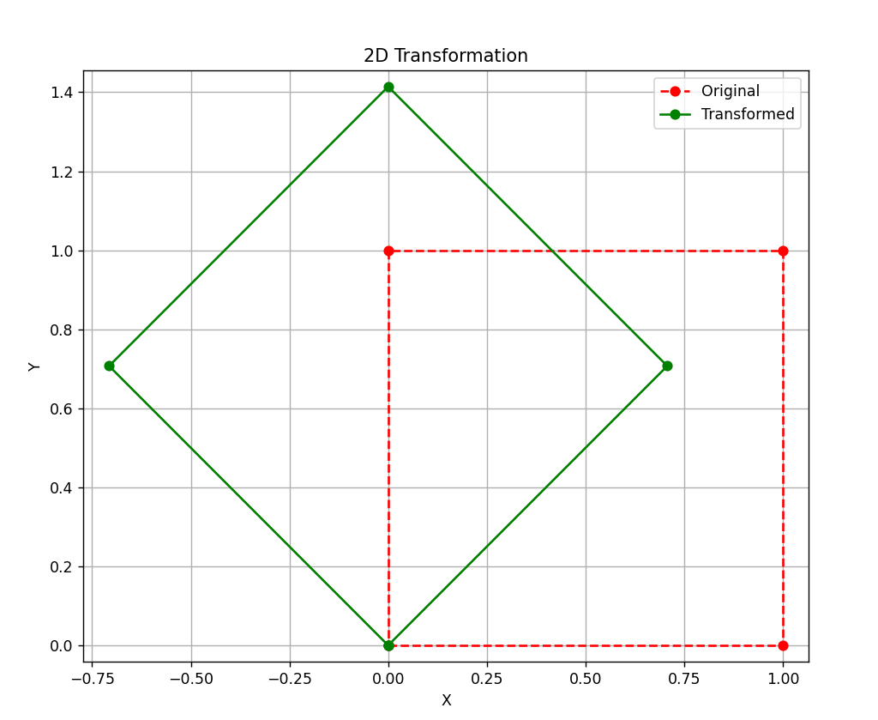

- WAP to draw Bezier and Hermite Curve.

import numpy as np
import matplotlib.pyplot as plt

def bezier(P0, P1, P2, P3, t):
return ((1 - t)**3)[:, None] * P0 + (3 * (1 - t)**2 * t)[:, None] * P1 + (3 * (1 - t) * t**2)[:, None] * P2 + (t**3)[:, None] * P3

def hermite(P0, P1, T0, T1, t):
h1, h2 = (2*t**3 - 3*t**2 + 1)[:, None], (t**3 - 2*t**2 + t)[:, None]
h3, h4 = (-2*t**3 + 3*t**2)[:, None], (t**3 - t**2)[:, None]
return h1 * P0 + h2 * T0 + h3 * P1 + h4 * T1

def get_points(n, prompt): return [np.array(list(map(float, input(f"{prompt} {i+1}: ").split()))) for i in range(n)]

def plot_curve(ctrl, curve, name):
plt.plot(*ctrl.T, 'ro--', label='Control Points')
plt.plot(*curve.T, 'b-', label=f'{name} Curve')
plt.title(f'{name} Curve'); plt.xlabel('X'); plt.ylabel('Y')
plt.legend(); plt.grid(True); plt.axis('equal'); plt.show()

def main():
print("1. Bezier Curve\n2. Hermite Curve")
choice = input("Choose (1 or 2): "); t = np.linspace(0, 1, 100)

if choice == '1':
P = get_points(4, "Bezier Point")
curve = bezier(*P, t); plot_curve(np.vstack(P), curve, "Bezier")

elif choice == '2':
P0, P1 = get_points(2, "Endpoint")
T0, T1 = get_points(2, "Tangent")
curve = hermite(P0, P1, T0, T1, t)
plot_curve(np.vstack([P0, P1]), curve, "Hermite")
else:
print("Invalid choice.")

if __name__ == "__main__":
main()

OUTPUT
Bezier Curve
1. Bezier Curve
2. Hermite Curve
Choose (1 or 2): 1
Bezier Point 1: 0 0
Bezier Point 2: 1 3
Bezier Point 3: 3 3
Bezier Point 4: 4 0
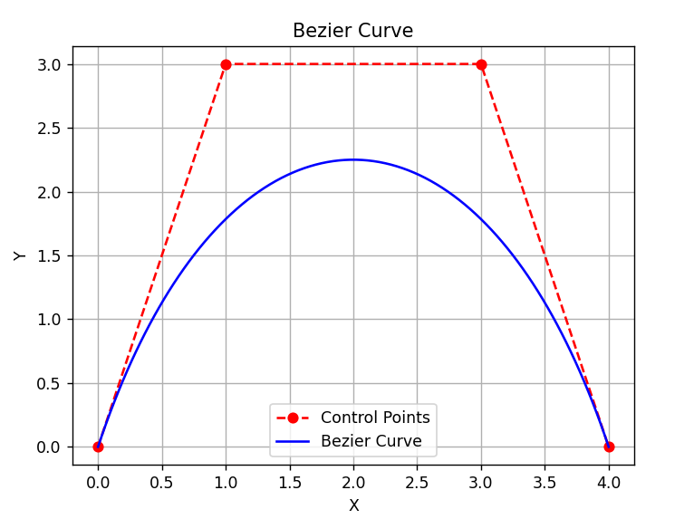
Hermite Curve
1. Bezier Curve
2. Hermite Curve
Choose (1 or 2): 2
Endpoint 1: 0 0
Endpoint 2: 4 0
Tangent 1: 1 3
Tangent 2: 1 -3
